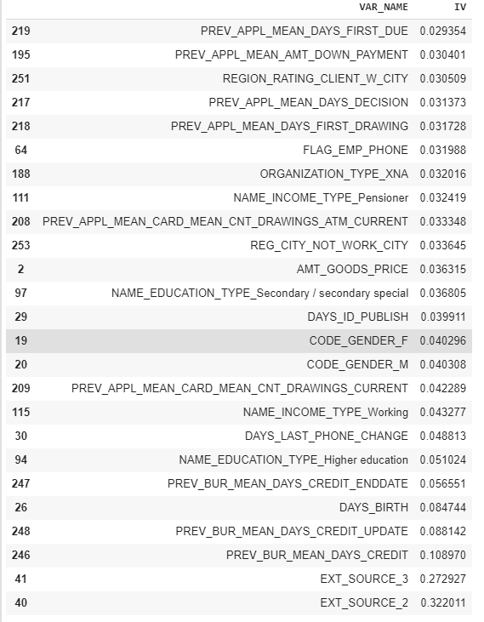

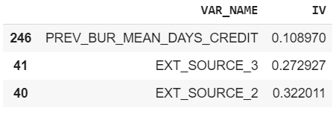

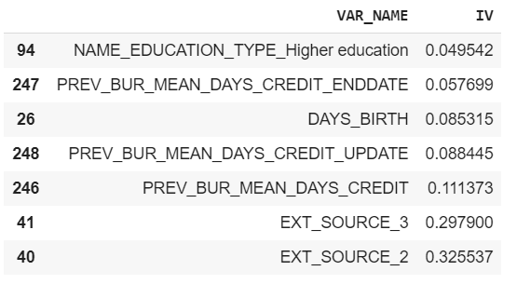

# Flag to represent when Total income is greater than Credit

train['INCOME_GT_CREDIT_FLAG'] = train['AMT_INCOME_TOTAL'] > train['AMT_CREDIT']

# Column to represent Credit Income Percent

train['CREDIT_INCOME_PERCENT'] = train['AMT_CREDIT'] / train['AMT_INCOME_TOTAL']

# Column to represent Annuity Income percent

train['ANNUITY_INCOME_PERCENT'] = train['AMT_ANNUITY'] / train['AMT_INCOME_TOTAL']

# Column to represent Credit Term

train['CREDIT_TERM'] = train['AMT_CREDIT'] / train['AMT_ANNUITY']

# Column to represent Days Employed percent in his life

train['DAYS_EMPLOYED_PERCENT'] = train['DAYS_EMPLOYED'] / train['DAYS_BIRTH']

# Shape of Application data